**North Western University**



**Project Title: Chat Web-Application**

**Course title: Software Engineering (Sessional) Final Report**

**Course code: CSE-434**

**GitHub Link:**

**Department: Computer Science and Engineering**

**Name and Student Id**

**Name: Fahim Habib ID:20201016910**

**Name: Hirak Mondal ID:20201046010**

**Name: Sajib Bhattacharjee ID:20201070010**

|  |  |  |  |  |  |  |
| --- | --- | --- | --- | --- | --- | --- |
|  | Name | ID | **Contribution of this project** | Email | Phone | Remarks |
|  | 1.Famim Habib  2.Hirak Mondal  3.Sajib Bhattacharjee | 20201016910  20201046010  20201070010 | Architectural Design  Frontend  Backend | sajibkumar.sk15@  gmail.com | 017  01400705050  01708009080 |  |

**Executive Summary**

**Table of Contents**

|  |  |  |
| --- | --- | --- |
| SN | Topic | Page no. |
| 1. | Introduction |  |
|  | 1.1 Goals and Objectives of the project |  |
|  | 1.2 Scope of the work |  |
|  | 1.2.1. Current situation and context |  |
|  | 1.2.3. Competing products (available in market) |  |
|  | 1.3. System overview |  |
|  | 1.4. Structure of the document |  |
|  | 1.5. Terms, Acronyms, and Abbreviations Used |  |
| 2. | Requirement Specifications |  |
|  | 2.1. Stakeholders for the system |  |
|  | 2.2. Use case diagram with Graphical and Textual Description |  |
|  | 2.3. Activity Diagram |  |
|  | 2.4. Static model – class diagram |  |
|  | 2.5. Dynamic model – sequence diagram |  |
| 3 | Architecture |  |
|  | 3.1. Architectural model/style used |  |
|  | 3.1.1. Rationale for choosing your architectural model/style |  |
|  | 3.2. Data Base Architecture |  |
|  | 3.2.1. Entity-Relationship (E-R) Diagram |  |
|  | 3.2.2 Technology, software, and hardware used |  |
| 4. | Design |  |
|  | 4.1. Component level design following pattern |  |
|  | 4.2. GUI (Graphical User Interface) design |  |
| 5. | Acknowledgment |  |
| 6. | References |  |

List of Figures

1. Stakeholders for the system

2. Use case diagram with Graphical and Textual Description

3. Activity Diagram

4. Static model – class diagram

5. Dynamic model – sequence diagram

6. Architectural model/style used

7. Rationale for choosing your architectural model/style

8. Data Base Architecture

9. Entity-Relationship (E-R) Diagram

10. Component level design following pattern

11. GUI (Graphical User Interface) design

List of Tables

N/A

1. Introduction

1.1 Goals and Objectives of the project

Messaging apps now have more global users than traditional social networks, meaning they will play an increasingly important role in the delivery of digital journalism in the future. While chat platforms initially rose to prominence by offering a low-cost, web-based alternative to SMS, over time they have evolved into multimedia hubs that support photos, videos, games, payments and more.

But for any particular company or private organization that needs their own customized app for their convenience that's why we-

We have developed our application mainly considering the use of a particular field, it may be an office or a private organization.

Although there are many apps available online, we have developed this app to provide certain facilities by considering some security issues, through which an admin can easily create the profile of other employees and can handle it himself, due to which any employee and admin can easily communicate with each other. Information will be shared and tasks performed

Also while developing this web application we have tried to keep security in mind and present it and every content in a simple way so that every employee and user can easily use and understand it and also easily share information with each other.

**1.2 Scope of the work**

1.2.1. Current situation and context

We have successfully developed the application still working on internal development so that users can understand and use it easily and trying to add more functionality.The app is working fine and we want to test it frequently to fix any bugs. We will soon deploy its free hosting provider Heroku and the public for testing.

1.2.3. Competing products (available in market)

Currently, there are many chat applications available in the play store and google but they are used for different purposes our application is entirely developed by ourselves for any professional or private company which only creates a personal connection between admin and user through which information can be exchanged easily. In a nutshell, it is a customizable chatting application.

1.3. System overview

We have divided our chat application into three web pages.

Page1: Login Page

Page2: Chats

Page3: Users(Only Admin can access)

**🡪Login Page:**

It is the front page i.e. user login page in which you can log in with your email and password if you are a valid user then you will be logged in otherwise you will not be logged in your acceptance will be declined.

**🡪Chats :**

After login users will come to the chat page and from here can share chat, audio, and video images with each other. Here we have added file functionality time management and authentication in the backend.

**🡪Users:**

Only admin will have access to this page. Admin can create and delete users and accordingly he will set a password and email address and through that user or employee can login and exchange information with each other.

1.4. Structure of the document

1.5. Terms, Acronyms, and Abbreviations Used

No Terms, Acronyms, and Abbreviations are Used.

2. Requirement Specifications

2.1. Stakeholders for the system

2.2. Use case diagram with Graphical and Textual Description

Use case diagram

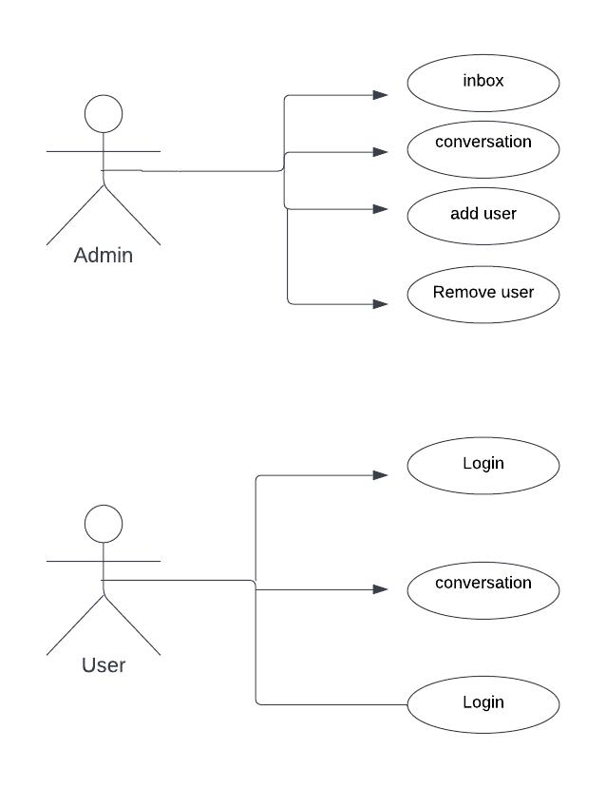

2.3. Activity Diagram

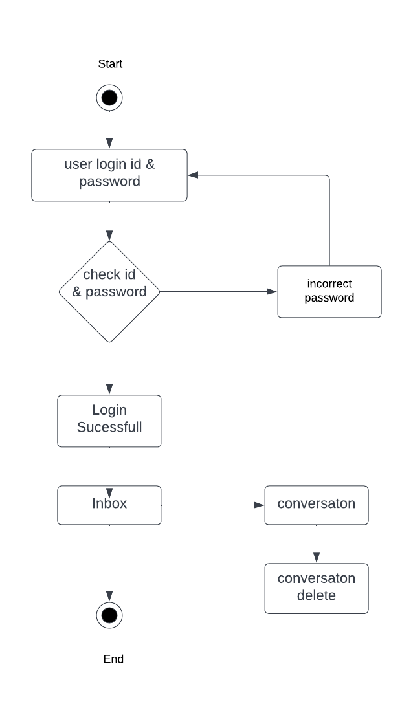 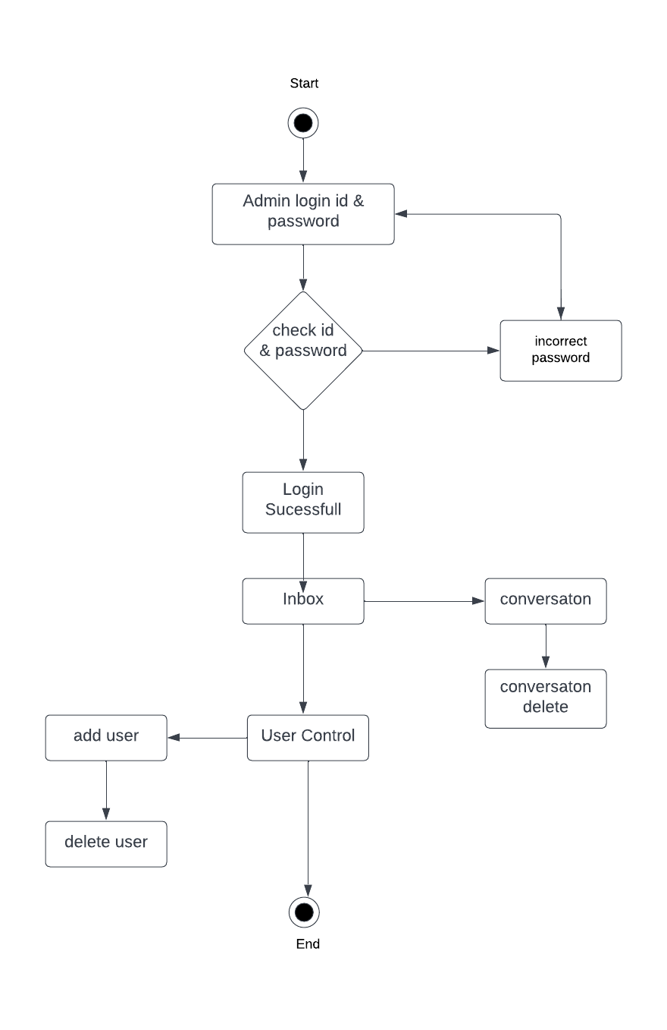

2.4. Static model – class diagram

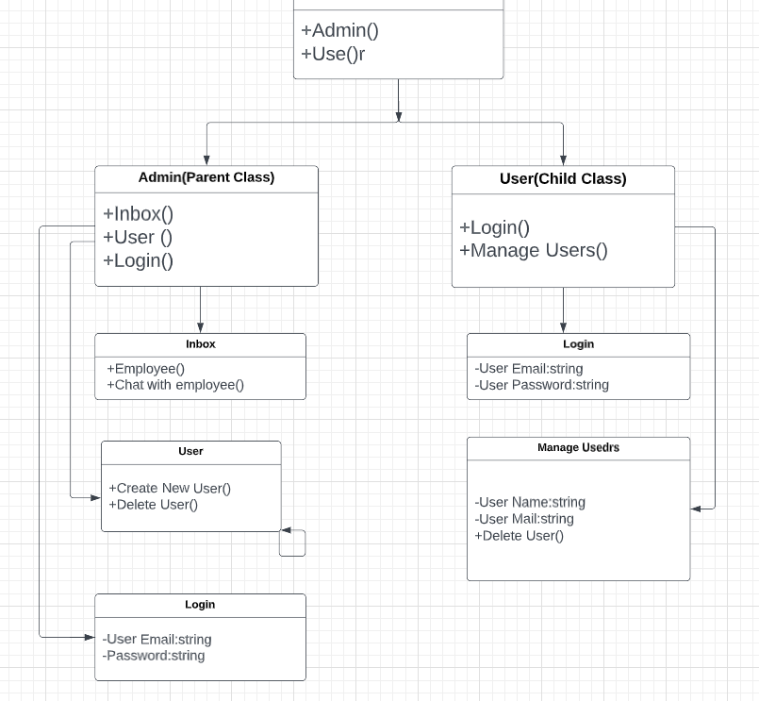

2.5. Dynamic model – sequence diagram

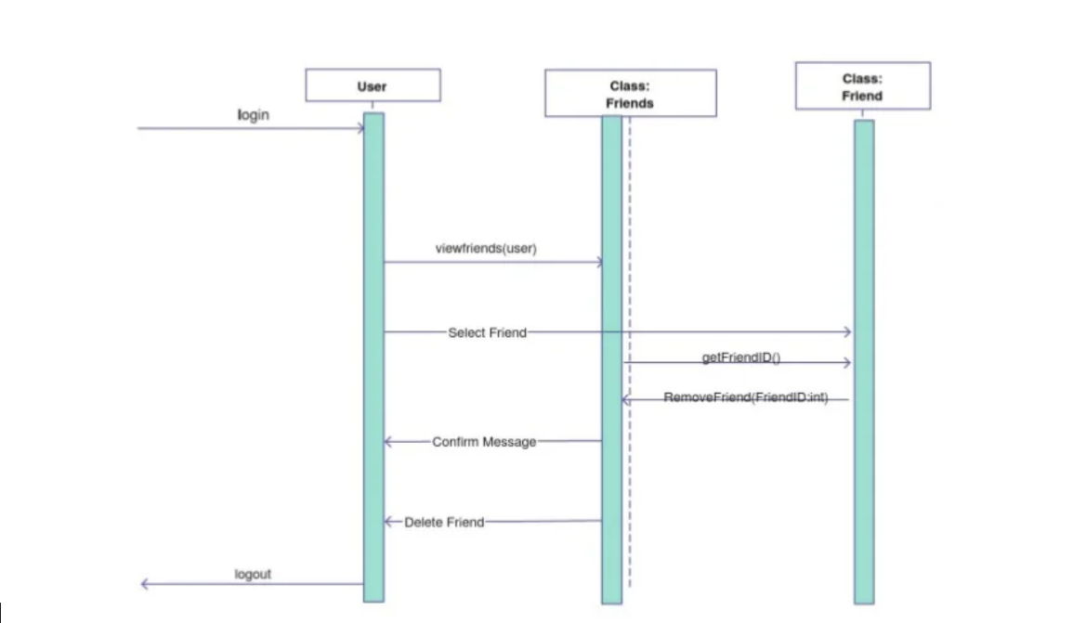

3. Architecture

3.1. Architectural model/style used

3.1.1. Rationale for choosing your architectural model/style

3.2. Data Base Architecture

3.2.1. Entity-Relationship (E-R) Diagram

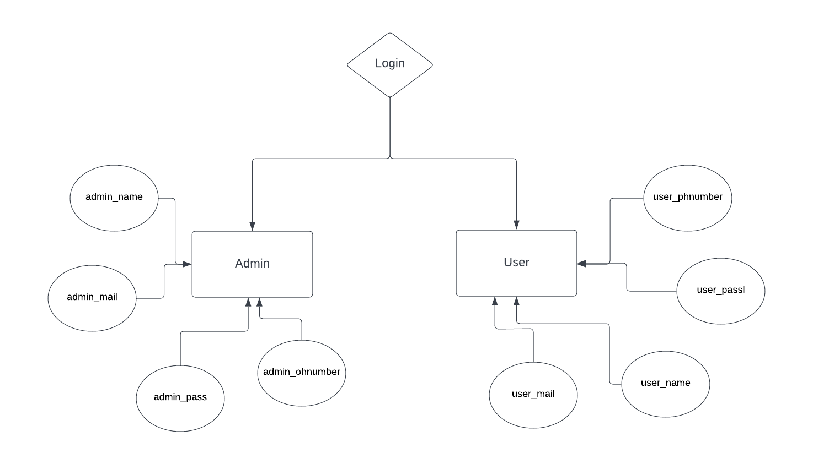

3.2.2 Technology, software, and hardware used

**Technology:**

HTML, CSS, JAVASCRIPT, NODE.JS, EXPRESS.JS, MONGODB, NPM PACKAGE ETC.

**Software:**

Operating System: Windows

Microsoft Visual Studio, MongoDB Compass

**Hardware Used:**

Chipset: intel CORE i5

RAM-8GB

ROM- 1 TB

Monitor, Mouse, Keyboard

4. Design

4.1. Component level design following pattern

4.2. GUI (Graphical User Interface) design

**Login Page:**

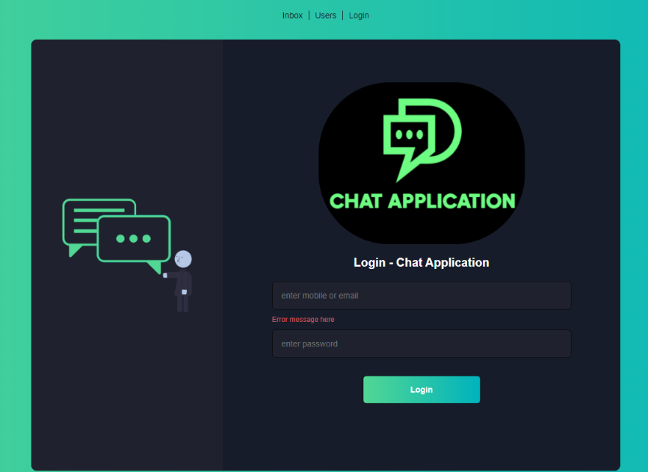

**Chats:**

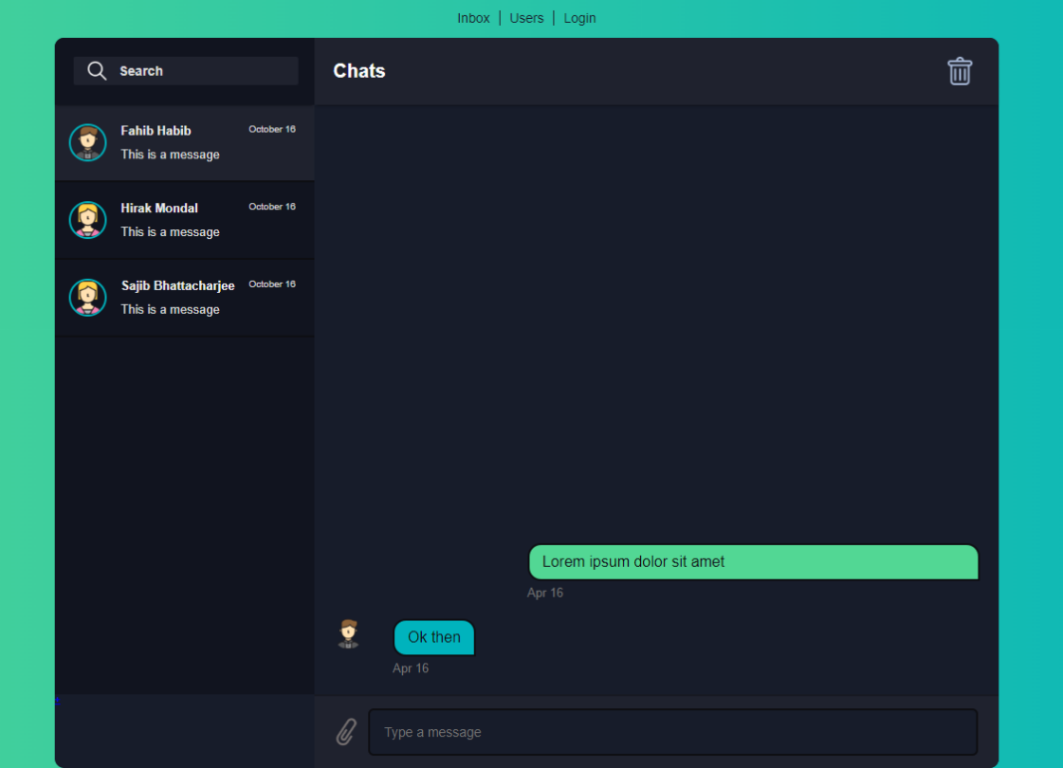

**Users:**

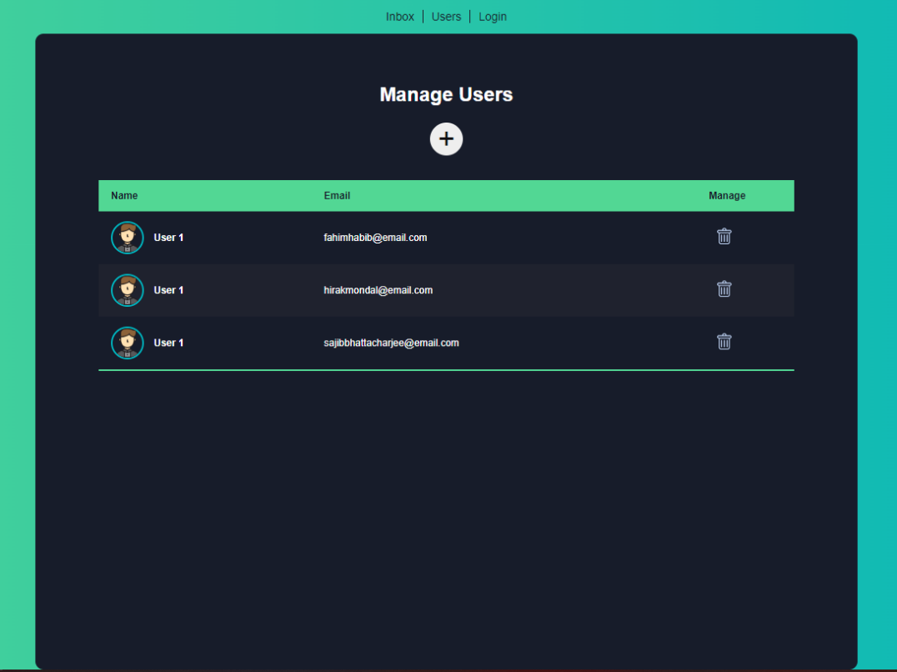

**Acknowledgment**

If words are considered as a symbol of approval and token of appreciation then let the words play the heralding role expressing my gratitude.

The satisfaction that accompanies that the successful completion of any task would be incomplete without the mention of people whose ceaseless cooperation made it possible, whose constant guidance and encouragement crown all efforts with success. We are grateful to our project guide **MD. Abu Nain Khan Sir** for the guidance, inspiration and constructive suggestions that helpful us in the preparation of this project. We also thank our colleagues who have helped in successful completion of the project.

-Team.

References (if Any)

(Must be complete, correctly formatted using the standard for IEEE Conference Proceedings)